**Problem 1**

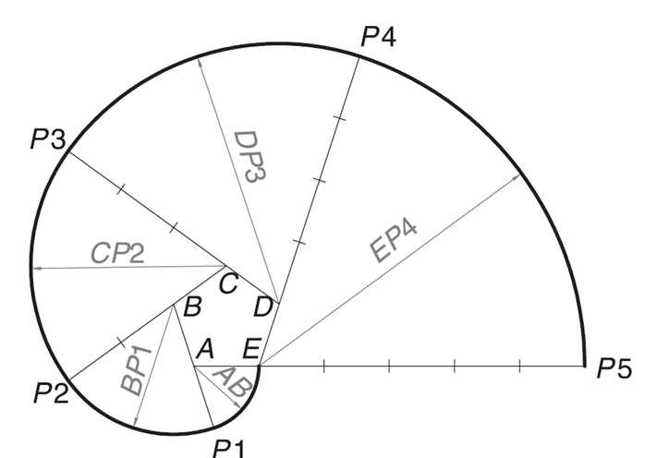

5 x 20 = 100 mm

**Problem 2**

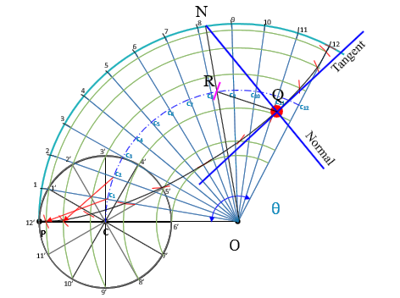

**OP = Radius of directing circle = 90 mm**

**PC = Radius of generating circle = 15 mm**

**θ = r/R x 360º = 15/90 x 360**° **= 60**°

**Problem 3**

OV = ½ of transverse axis = 150 / 2 = 75 mm

VK = Abscissa = 60 mm

MN = Double ordinate = 120 mm

Eccentricity = 1.5 > 1 => Conic is Hyperbola

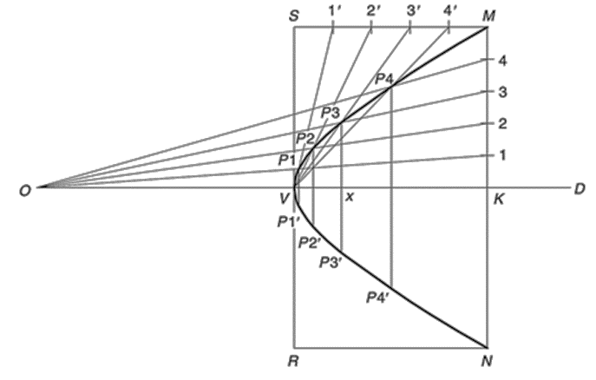

**Problem 4**

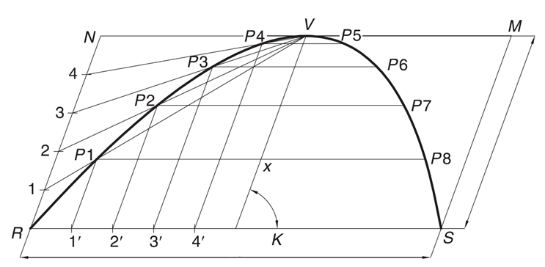

75º

60 mm

25 mm